

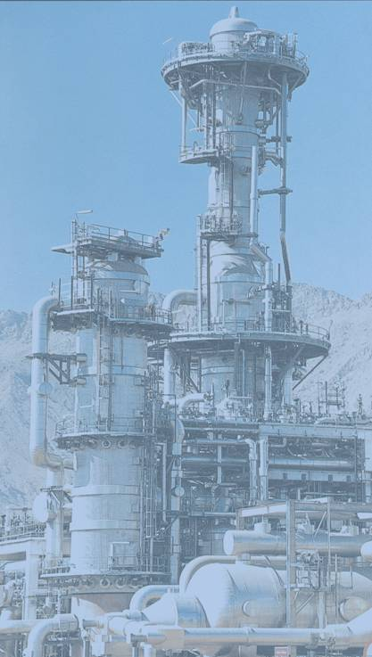
PRE-QUALIFICATION

2011

KOINS CO., LTD.

Head Office #11-2-3, S&M Business Industrial Complex, Hwachi-Dong,
& Factory Yeosu-Si, Jeollanam-Do, 555-280, Korea / koins@koins21.co.kr
TEL: +82-61-684-6862 / FAX : +82-61-684-6865

India #203, Veena Killedar Estate Pais Street Byculla West Mumbai,
Branch 400-011, India / cflim@koins21.co.kr
TEL : +91- 22-3266-0243 / FAX : +91-22-2309-1867

Contents

- the address of ceo
- KOINS 21TH VISION
- Koins Presentation
- Koins Profile
- Koins History
- Koins Organization
- manpower STATUS
- CertificateS & PATENT
- Partners in Tech & Business
- Jobs & SERVICES koins does
- Major customers
- Main equipments
- Main referenceS

Dear Sirs/Madams,

First, we are greatly happy that you allow us to present our company, Koins Co., Ltd., to you.

We KOINS Co., Ltd. has played its role and fulfilled its responsibility as one of the leading engineering contractors by growing constantly in the field of total maintenance and construction for oil refinery and petrochemical industry.

Our high technology in design, engineering, and fabrication of equipments and manufacturing of various pigs has been highly recognized by various customers in the domestic market as well as in the international market.

Moreover, according to its long term strategy to gain a competitive edge, KOINS has been diversifying into total maintenance system for bolt tensioning, catalyst loading & unloading and cleaning of heaters, pressure vessels, heat exchangers, pipelines and storage tanks as well as pigging of pipeline

KOINS provides customer satisfaction through a market-oriented mindset and management principles which are value creation, technical innovation and original intention, and will do the best to become a world-class total maintenance service company in accordance with KOINS vision of the 21st century.

We will exert our utmost effort to keep development of new technology and improvement of our products and services to meet the ever-changing requirements of our customers.
We look forward to your continued cooperation and support.
Thank you very much


President &CEO / Myung Hwan Choi

21th VISION

TOP CLASS OF THE WORLD
AT TOTAL MAINTENANCE SERVICE

VALUE CREATION
TECHNICAL INNOVATION ORIGINAL INTENTION

CUSTOMER SATISFACTION

-. TOTAL MAINTENANCE
-. ENGINEERING & CONSTRUCTION
-. MANPOWER SUPPLY

Unless otherwise challenge, bright future shall not be assured !

KOINS PROFILE

- Name of Company : KOINS Corporation Limited
- Address : #3 & 4, block 11-2, Imdaedanji, Yeosu Industrial Complex,
Hwachi-Dong, Yeosu-Si, Jeollanam-Do, 555-280, Korea.
- Website : http://www.koins21.co.kr
- Established : 25th, Jul, 2005
- Capital Stock : USD350,000.00
- Area of Factory : 3,300 m²
- For Contact
Head Office & Factory
11-2-3, S&M Business Industrial Complex, Hwachi-Dong,
Yeosu-Si, Jeollanam-Do, 555-280, Korea.
Tel : +82-61-684-6862 / Fax : +82-61-684-6865 / Koins@koins21.co.kr

India Office
24,Majithia indl . Estate, W.T. Pail Marg, Deonar, Mumbai-400088. INDIA
Tel : +91-22-6735-8989 / Fax : +91-22-6735-8999

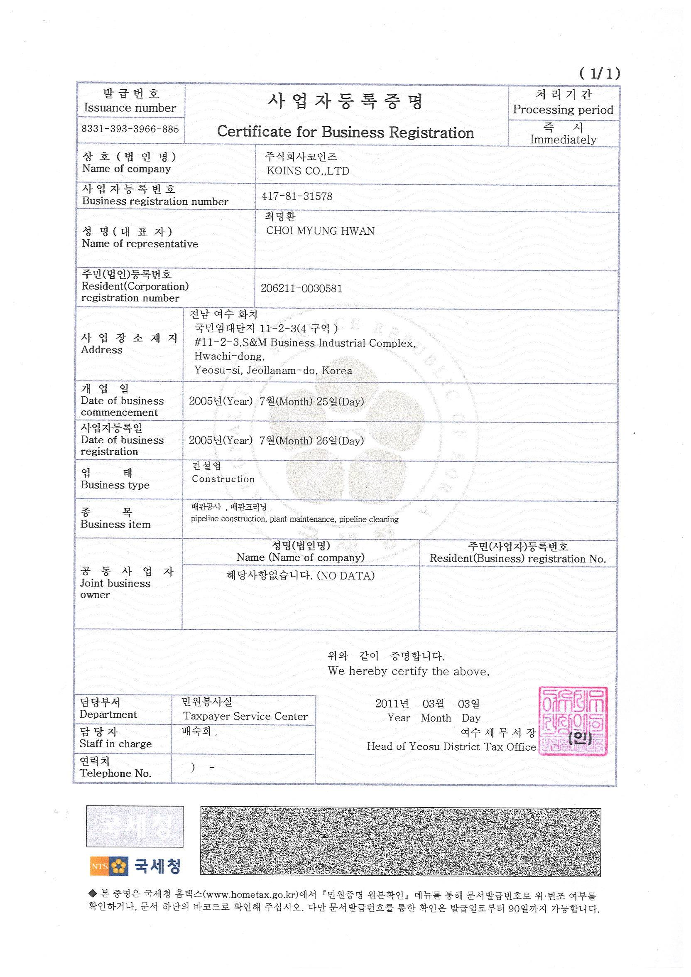
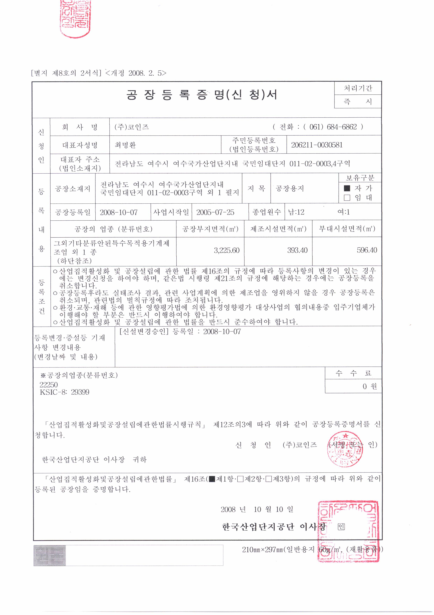
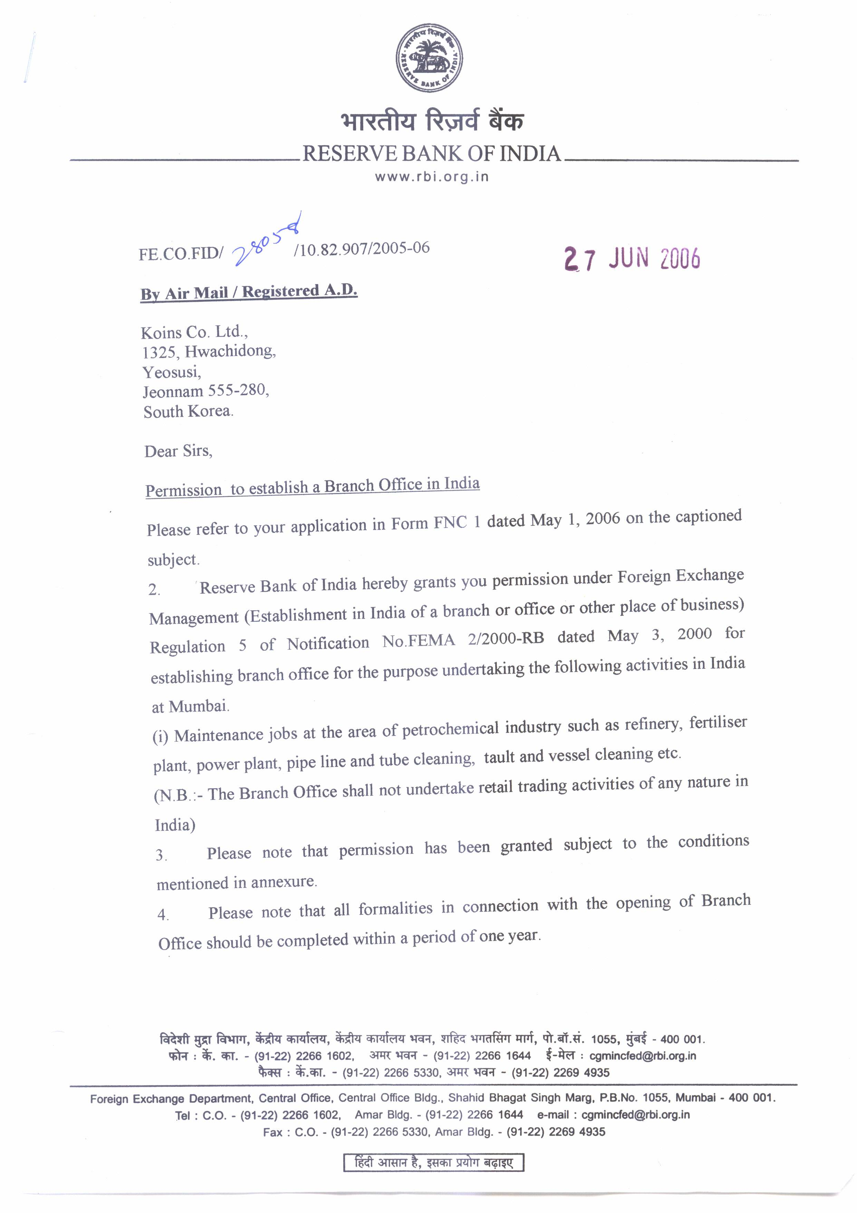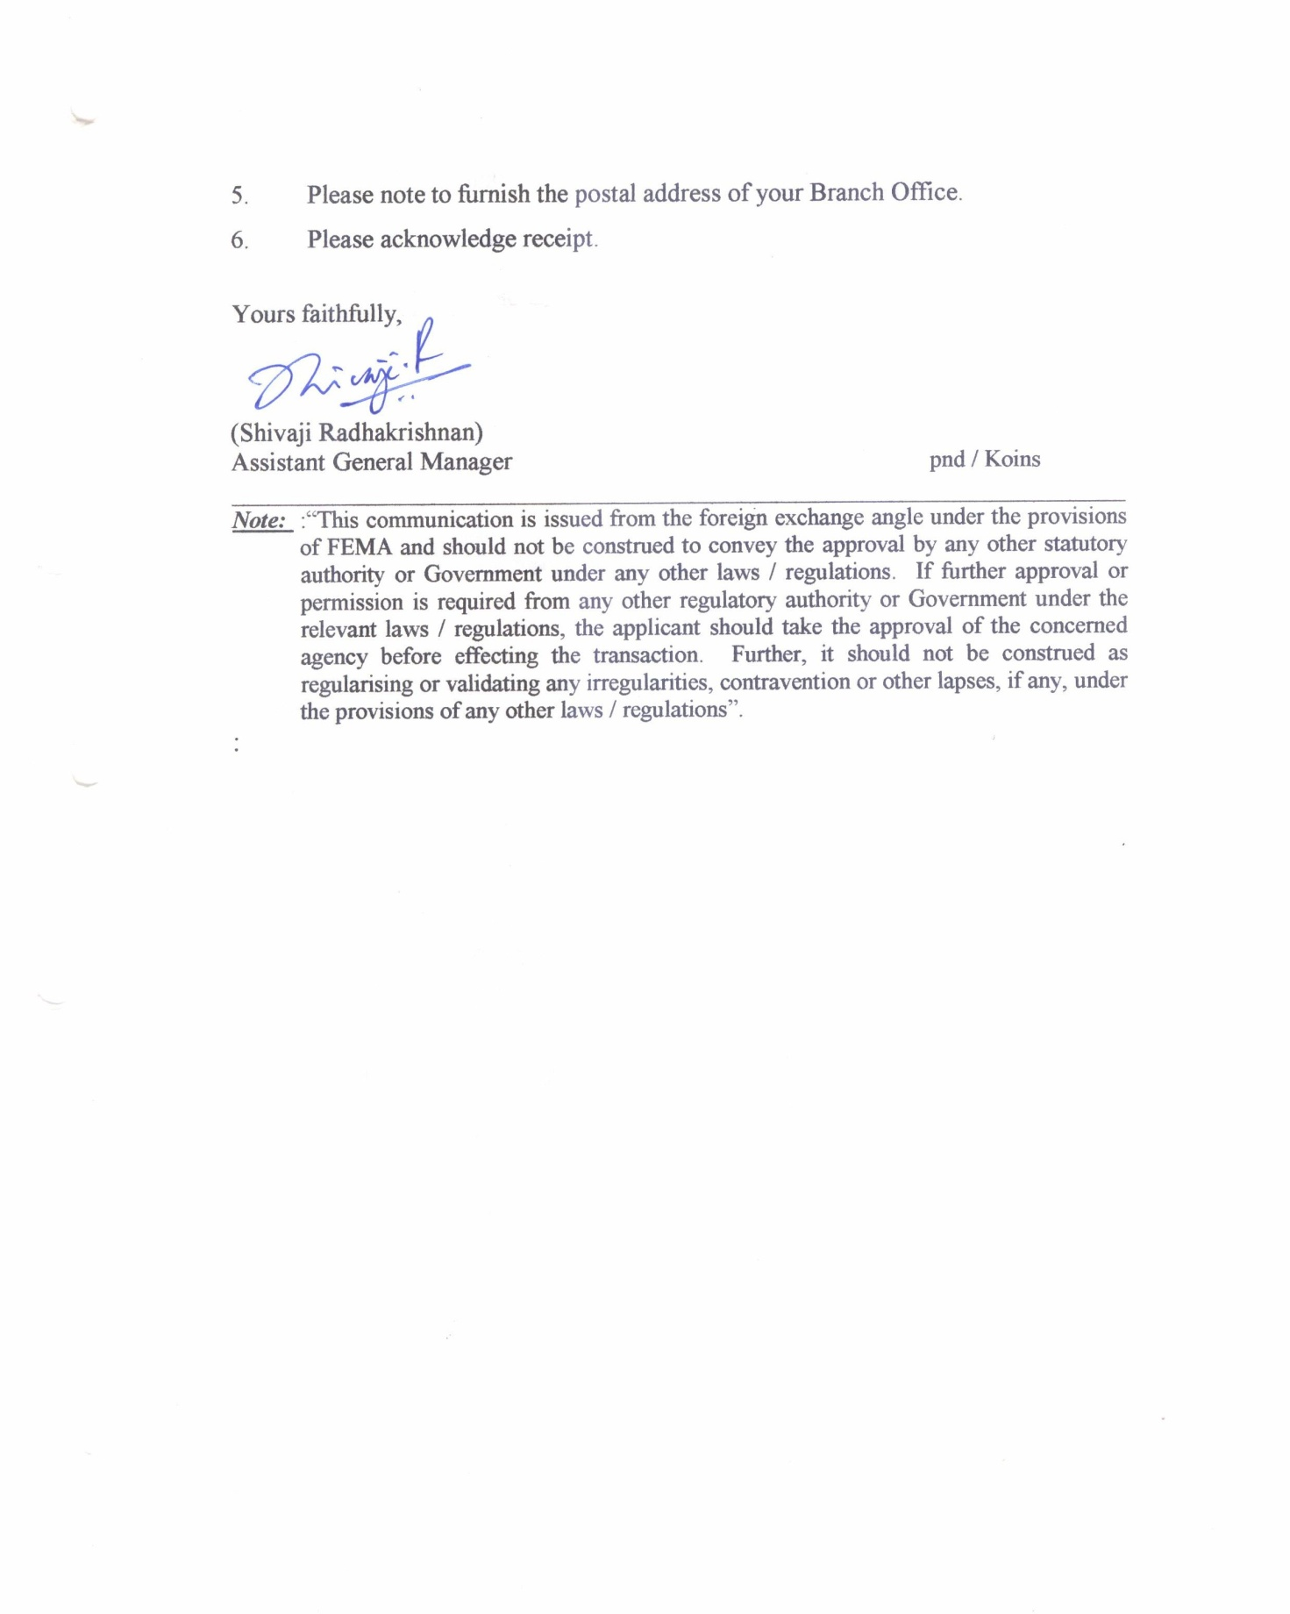

KOINS HISTORY

- July 2001 : Founded Plant division in Pusys Co., Ltd
- 2002 : Registered as a vendor in LG Petrochemical Co. Ltd.
- 2003 : Registered as a vendor in SK Corp.,Samsung Total Chemicals & S-Oil
- May 2005 : Plant division separated from Pusys Co., Ltd
- July 2005 : Established Koins Co., Ltd
- Sep 2005 : Opened Project Office in India
- Dec 2005 : Concluded partnership with Pigs Unlimited Inc, USA
- Dec 2005 : Concluded partnership with Time Services H. Gmbh, Germany
- Feb 2006 : Registered as a vendor in Reliance Group, India
- Jul 2006 : Acquired a membership from Korea National Trade Association
- Aug 2006 : Registered as a vendor in IPCL & IPCL, India
- Oct 2006 : Registered as a vendor in LG Chem. Co.
- Apr 2007 : Increase of Koins stock ( USD 200,000 → USD 350,000)
- Aug 2007 : Registered as a vendor in Essar Group, India
- Dec2007 : Concluded partnership with Rosen Inspection Technologies Sdn Bhd
Malaysia, ( Storage Tank Inspection & Intelligent Pigging )
- Feb2008: Concluded partnership with StarTrak, USA
- Jun 2008 : Acquired ISO 9901/ISO14001 Certificate
- Jun 2008 : Construction of New Koins Shop(For Pig production & general purpose)
- Dec2008 : Concluded partnership with Risen Global Technologies, UAE
- Mar2009 : Concluded partnership with Daechang Machinery Co.,Ltd
( For the Machinery Fabrication)
- May 2009 Concluded Partnership with SOS Australia for the Tube cleaning System
- May 2009 Acquired Sales Authorization with B&B Korea for the Ceramic Product

ORGANIZATION CHART
Date of May 2009
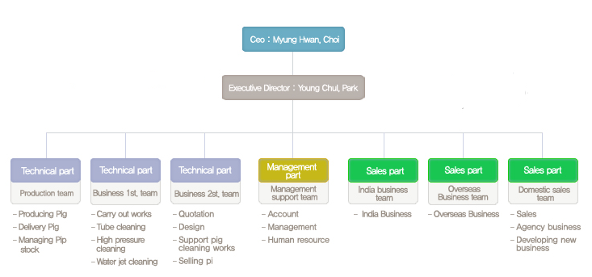

MANPOWER STATUS

 | Regular Staff | Temp. Worker | Total
HQ (Korea) | 20 | 45 | 65
Branch (India) | 24 | 150 | 174
TOTAL | 44 | 195 | 239

CERTIFICATES AND PATENT

- ISO9001 / ISO14001 CERTIFICATE
- Membership of Korea International Trade Association
- Certificate of Trade Business Number)

- PATENT

- Title : Pig passage signaler in mono-structure
Number : 0367161
Date : 30 Oct 2004
Designer : Myung-Hwan, Choi

- Title : Pig with the function of keeping off
breakaway of metal pins
Number : 0501806
Date : 10 Aug 2005
Designer : Myung-Hwan, Choi

- Title : Pipe cleaning system with the suction method
Number : 0501807
Date : 10 Aug 2005
Designer : Myung-Hwan, Choi

- Title : Dummy Pig & Pigging Method by dummy pigging
Number : 08-67806
Date : 11 July 2008
Designer : Myung-Hwan, Choi

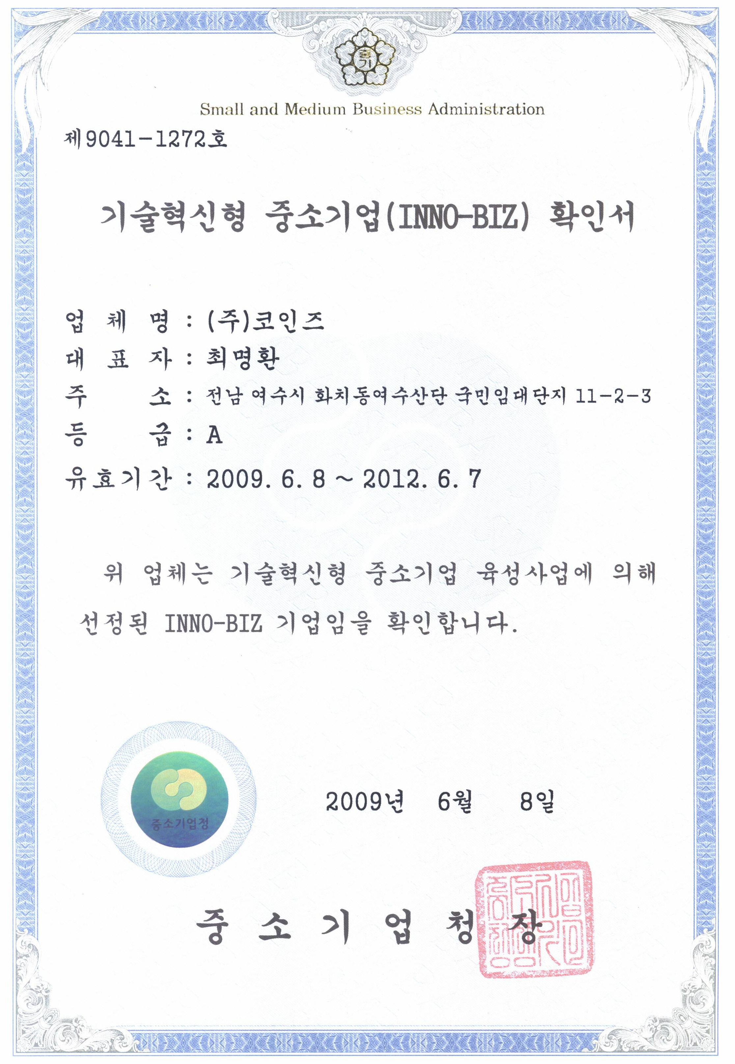
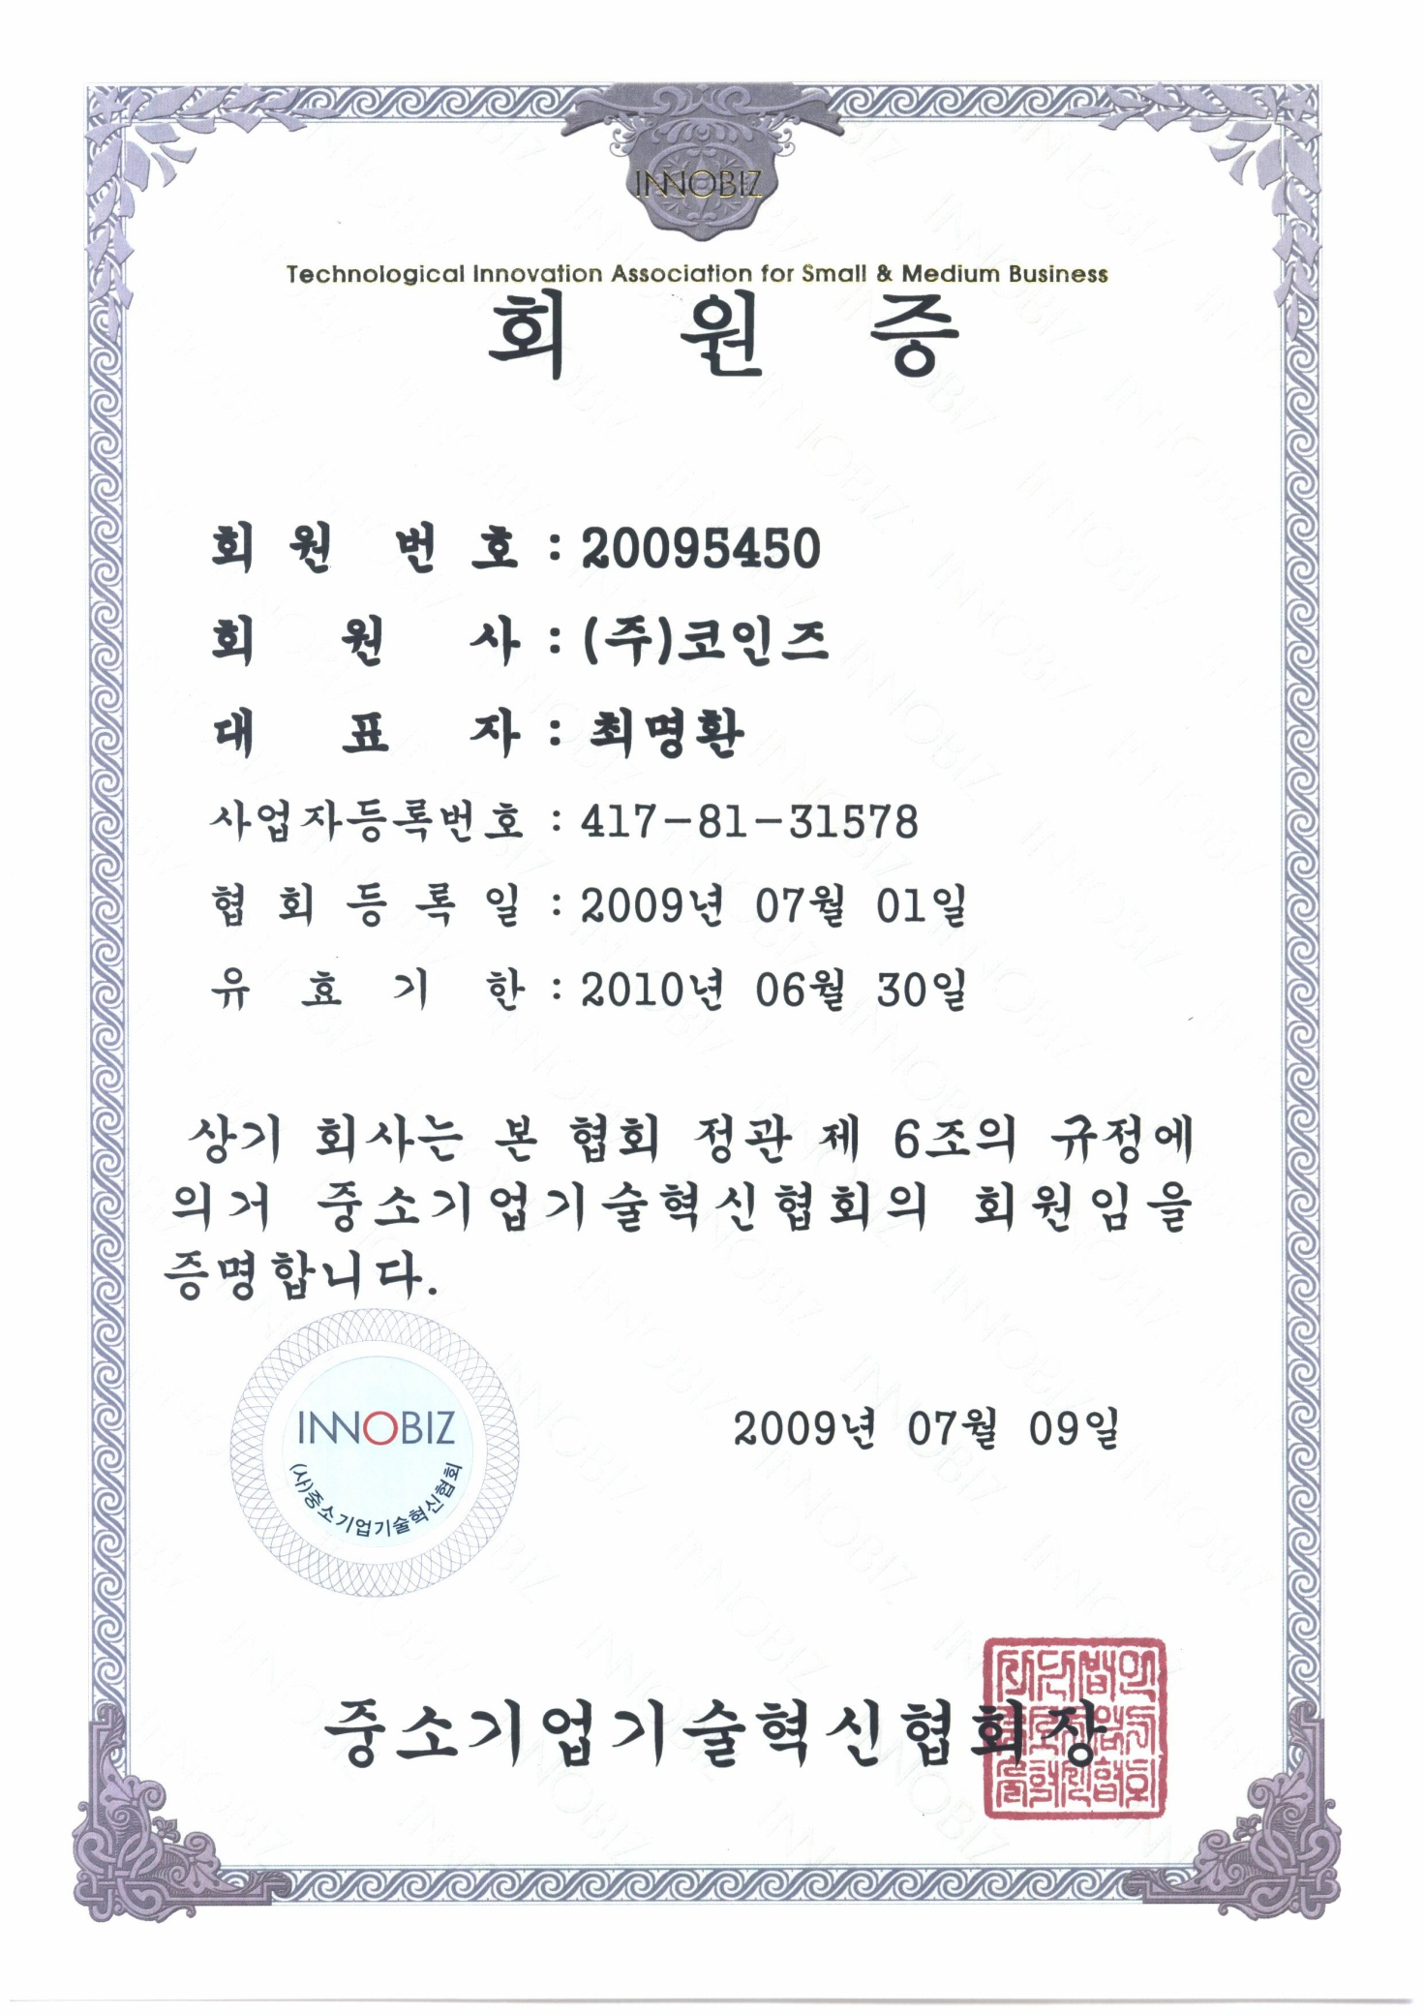
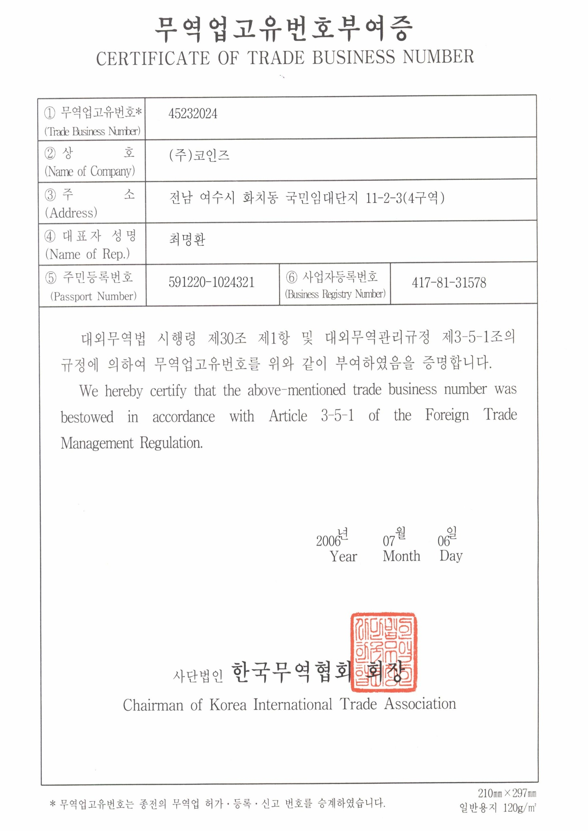
Partners AND TECHNICAL COOPERATION
  - DOMESTIC COMPANY
    - HIKOREA : Rubber foam insulator
- Home Page : www.okhiflex.com
    - TIOCHEM : Ceramic paint
- Home Page : www.tiochem.com
    - DAE SHIN PLANT CONSTRUCTION : Plant Equipment, Pipeline Construction
- Home Page : www.takeoff21.co.k
    - PIUSYS : Producing Polyurethane material
- Home Page : www.piusys.co.kr
    - HYOSUNG ENGINEERING : Pipeline Insulator Cover
- Home Page : www.escover.co.kr
  - FOREIGN COMPANY
- Pigs Unlimited Inc. (America)
- Supply special pig
- Home Page : www.pigsunlimited.com
- TOHKEI Industrial Co.,Ltd.(Japan)-Plant Maintenance business in Japan
- Home Page : www.polyunion.com
- Rosen Engineering (M)Sdn. Bhd (Malaysia)
- Intelligent Pigging
- Home Page : www.roseninspection.net
- Technotest Engineering Sdn.Bhd. (Malaysia)
- Plant Maintenance
- Home Page : www.techmotest.com.my
- Startrak Inc (America)
- Intelligent pigging using GPS
- Home Page : www.starpig.com
- Specialised Overhaul Service Pty Ltd (SOS)(Australia)
- Heat exchanger, condense tube cleaning
- Home Page : www.sostubecleaners.com
- Dynamic Staffing Services
- Man power supply to India and middle east
- Home Page : www.dss-hr.com
- Peterson Products co., Ltd. (USA)
- Manufacturing Stopper
- Home Page : www.pipeplug.com
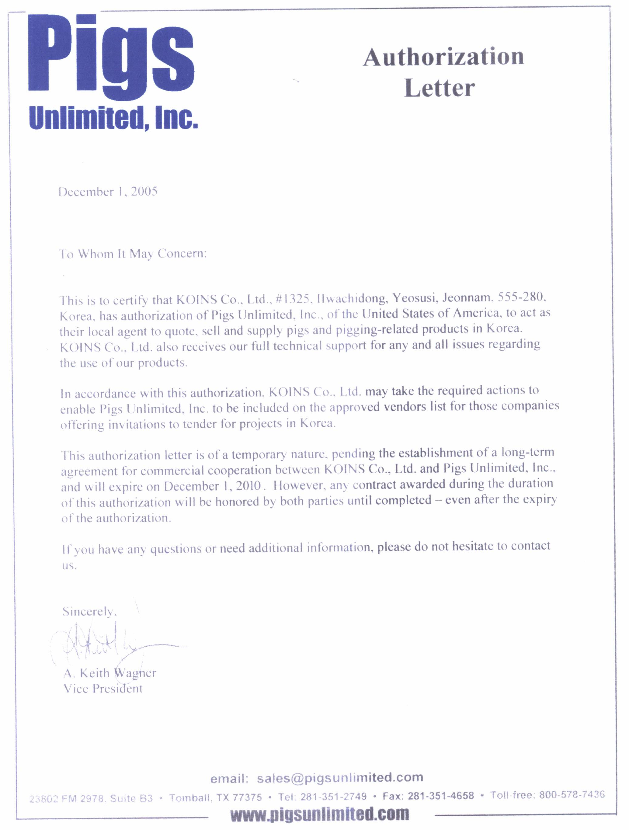
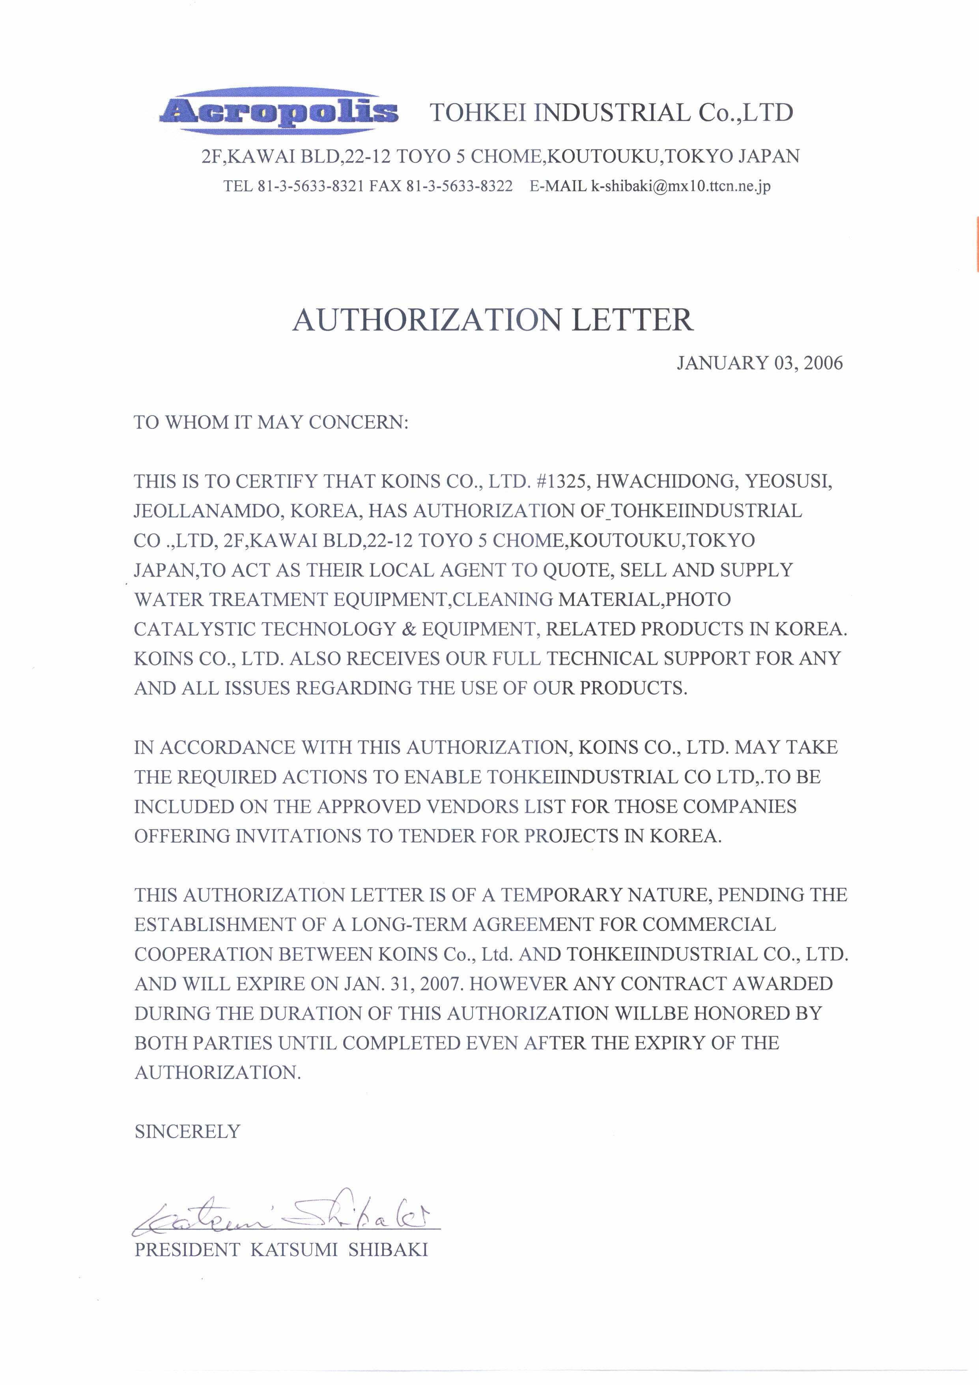

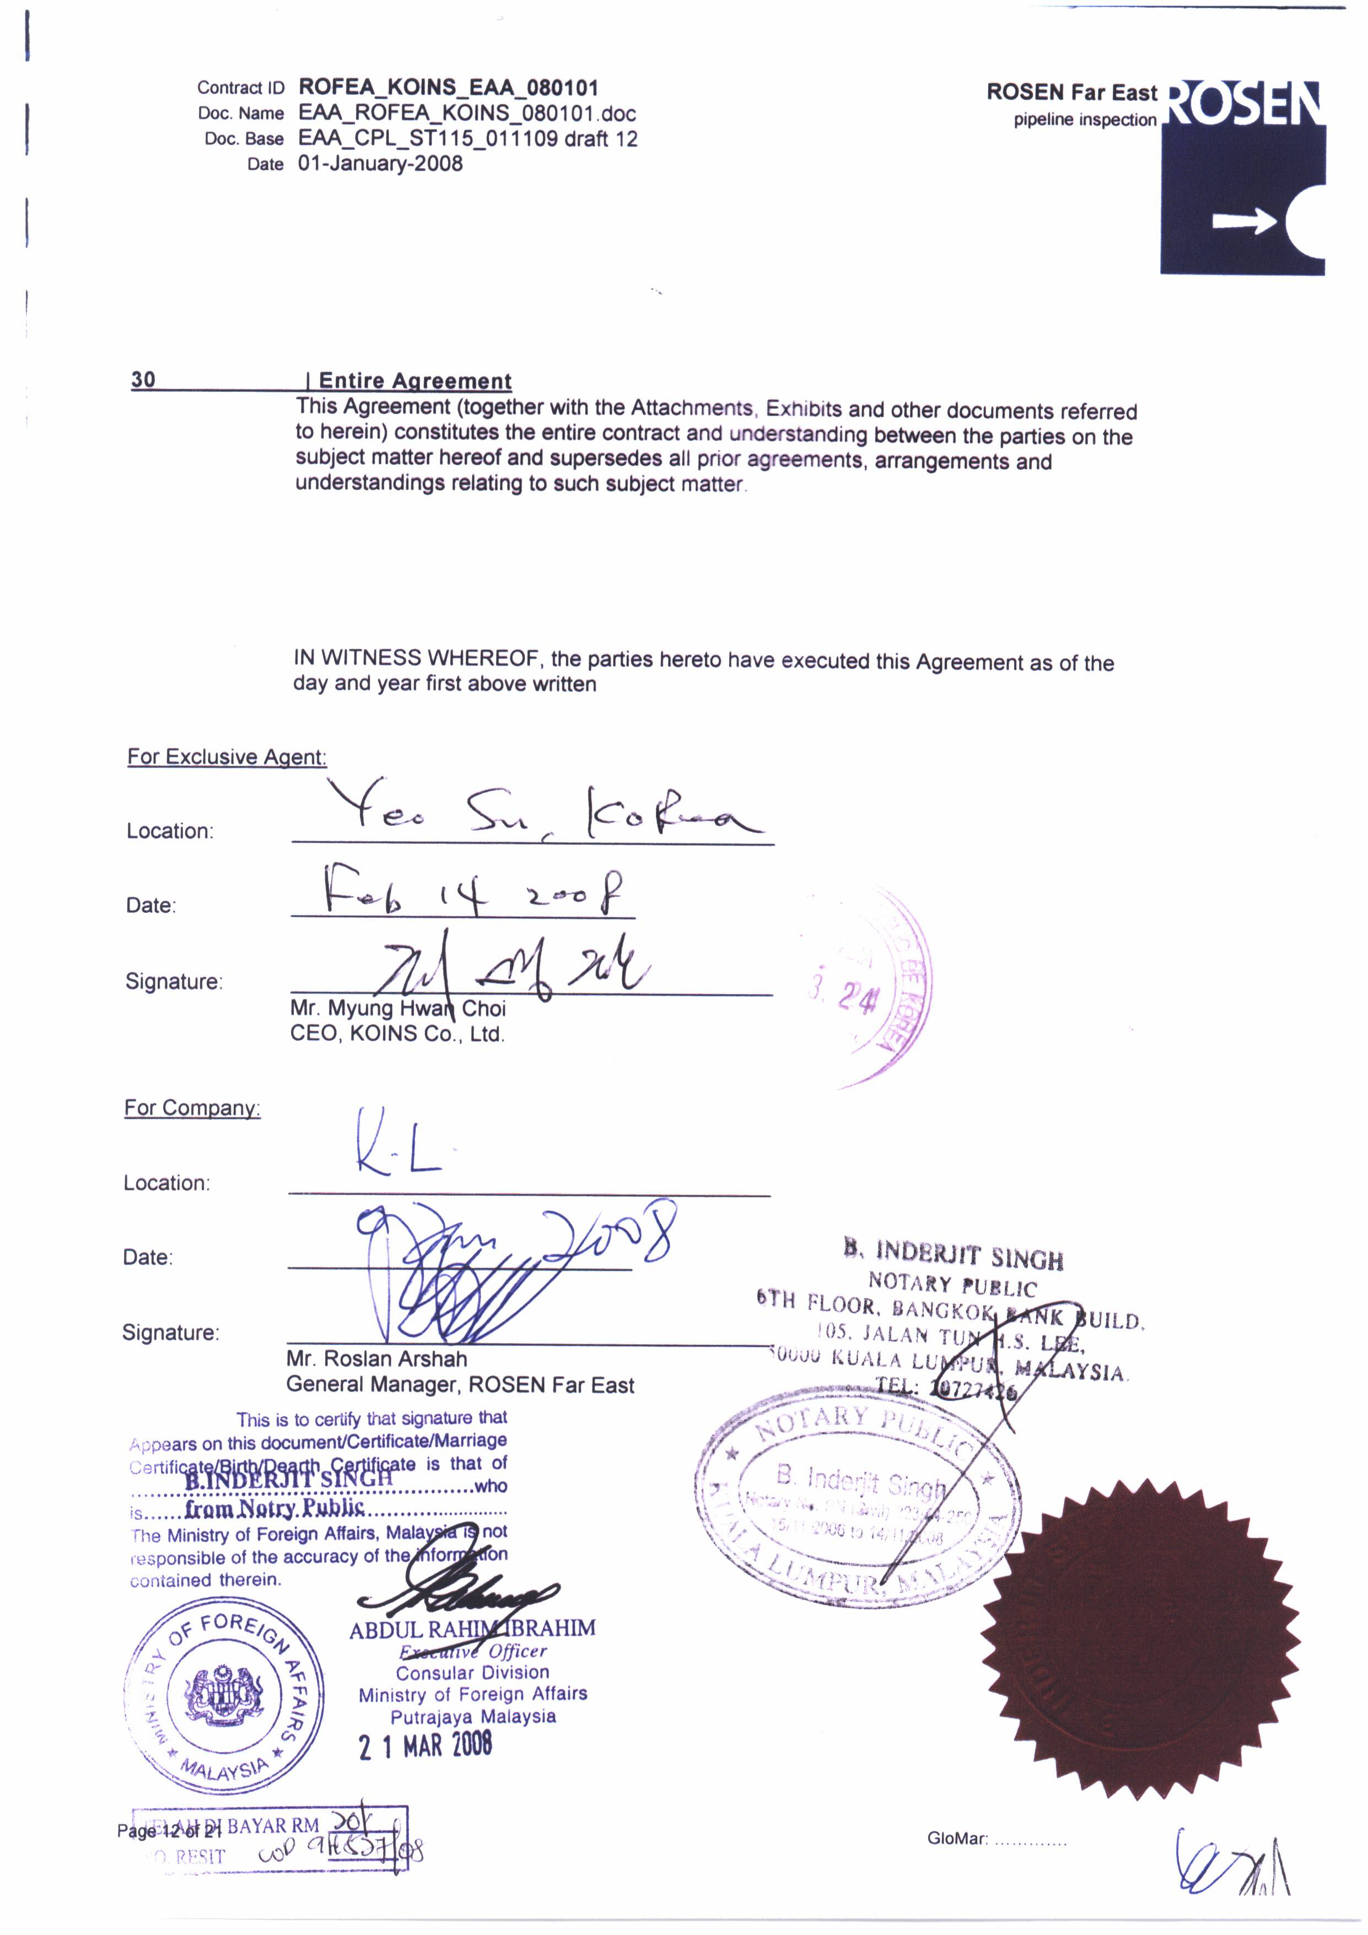
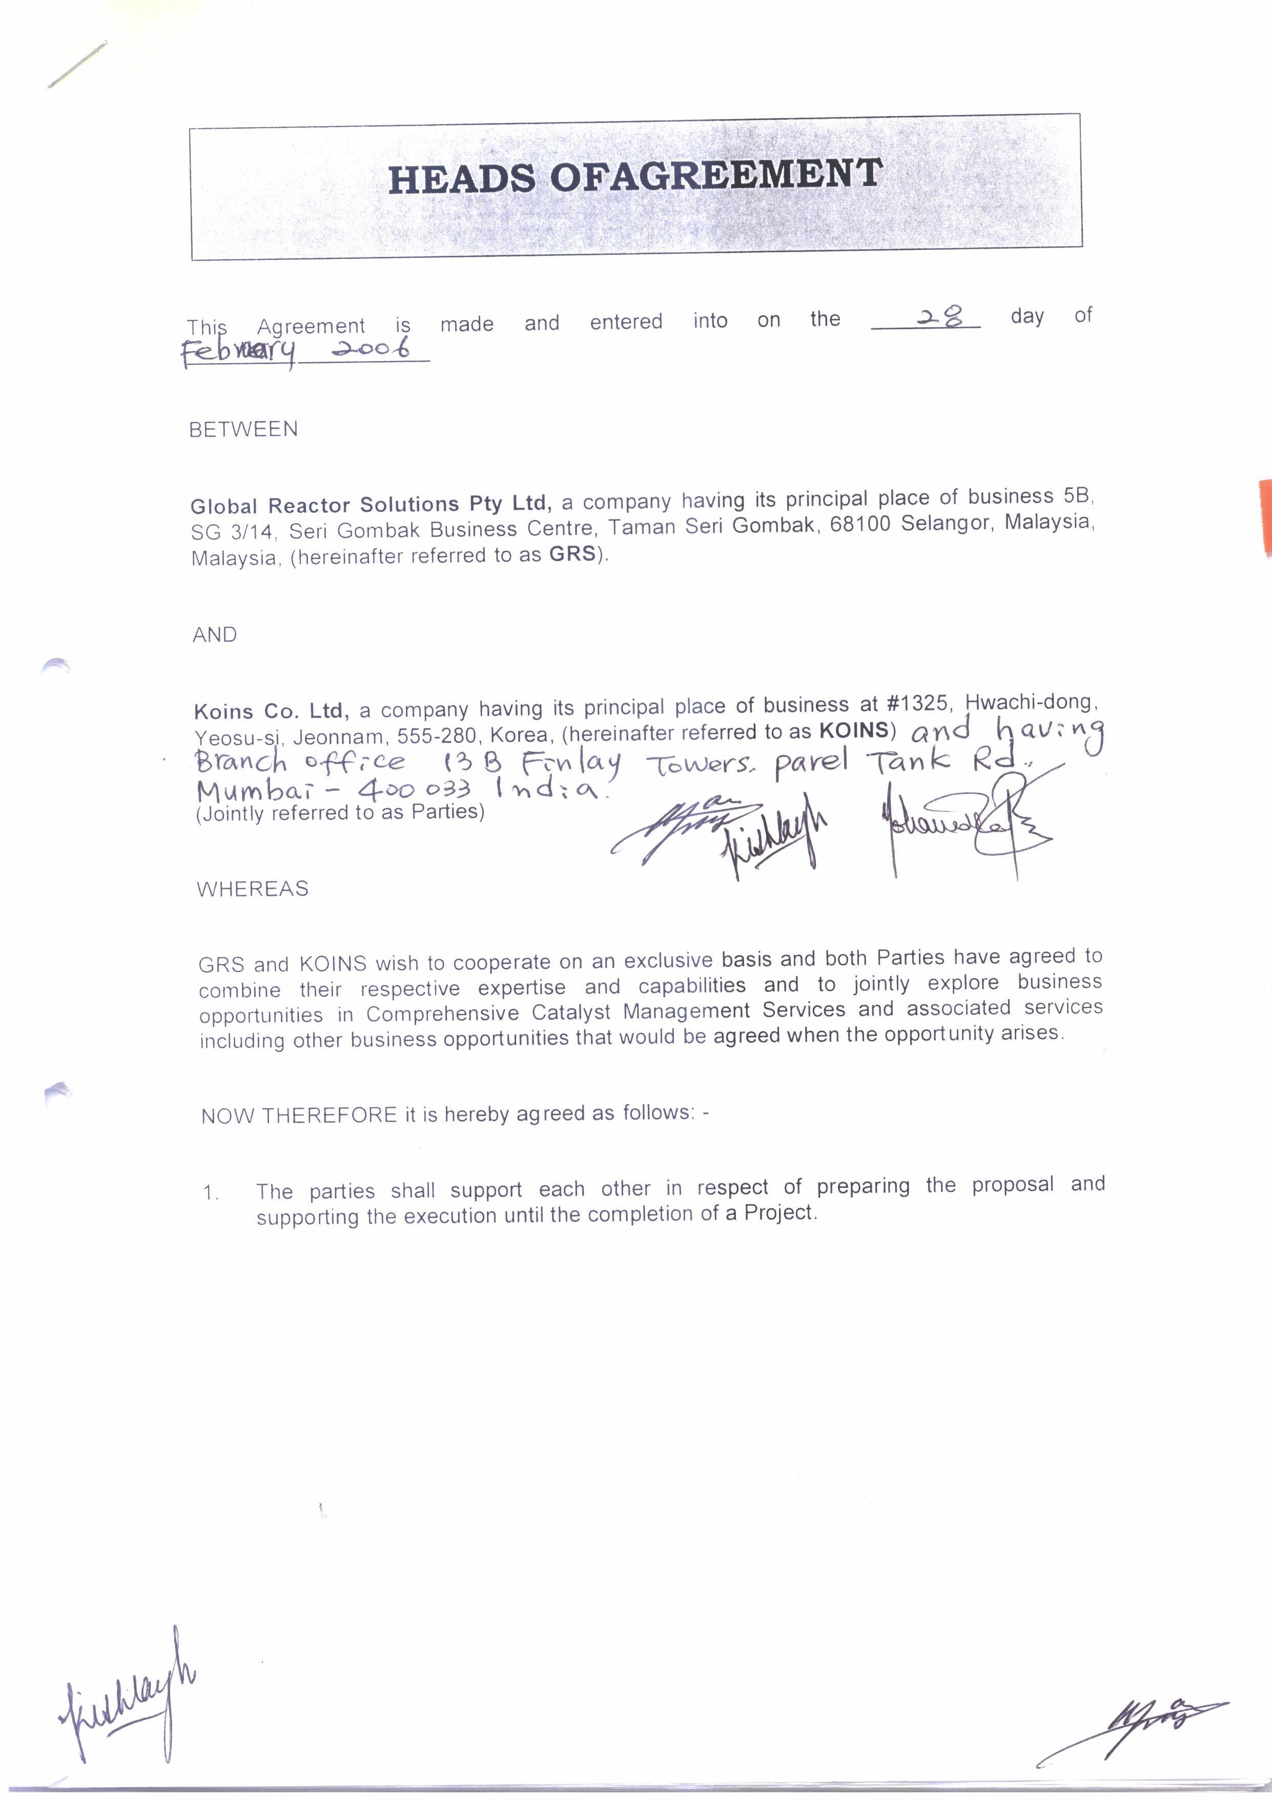
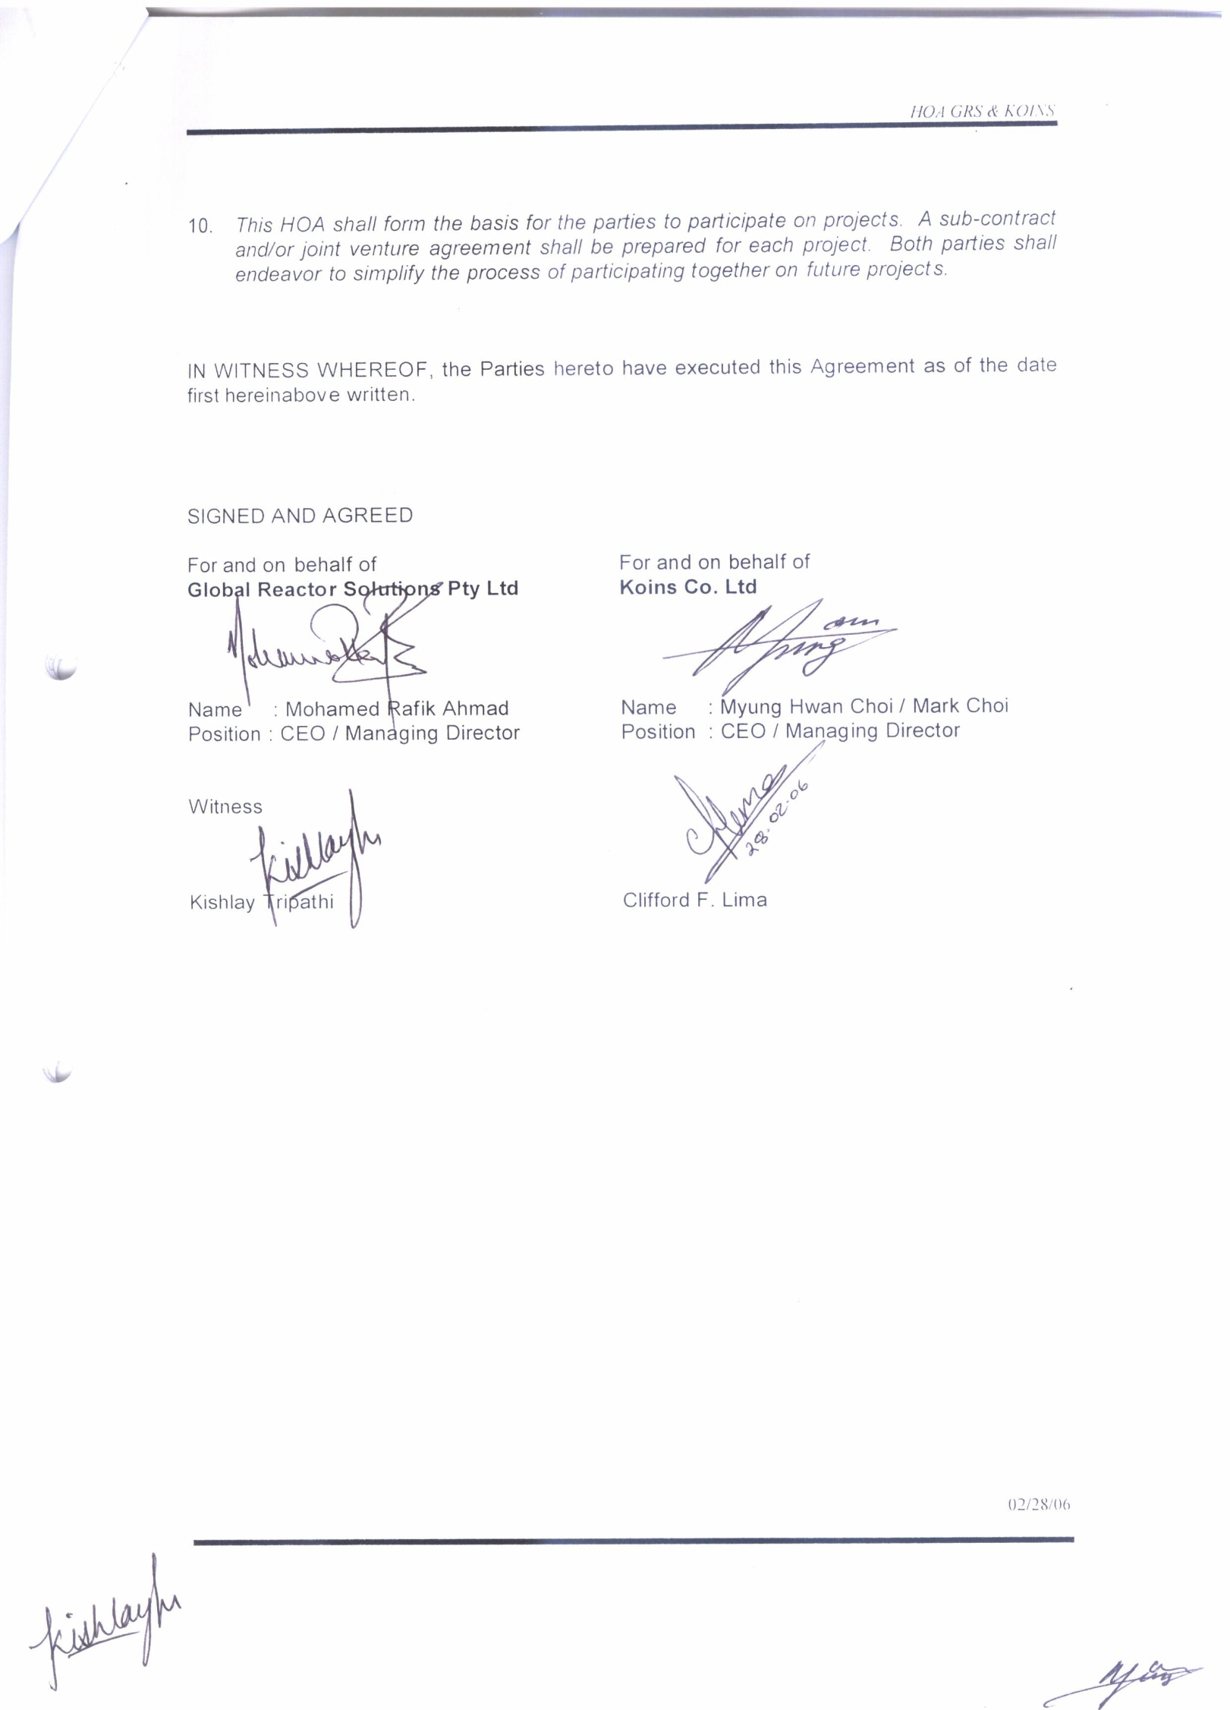
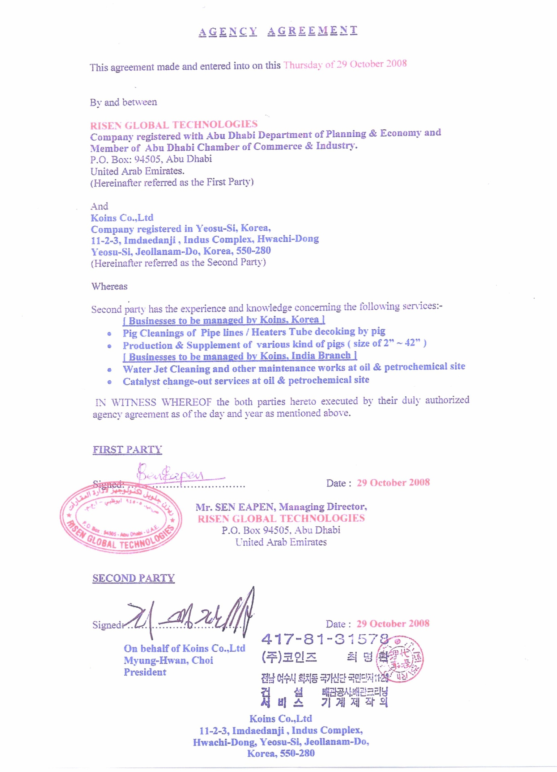

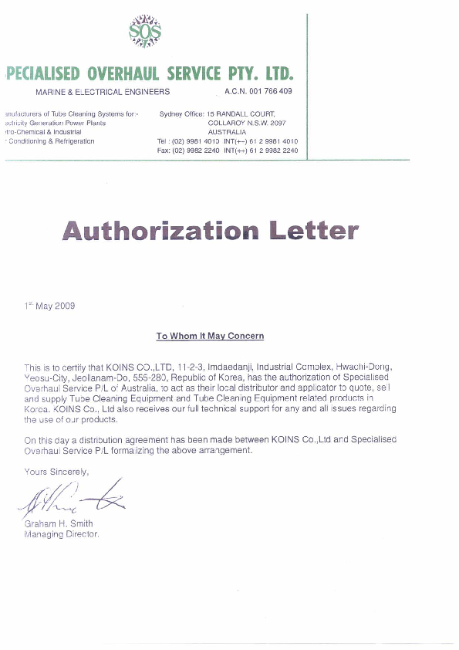

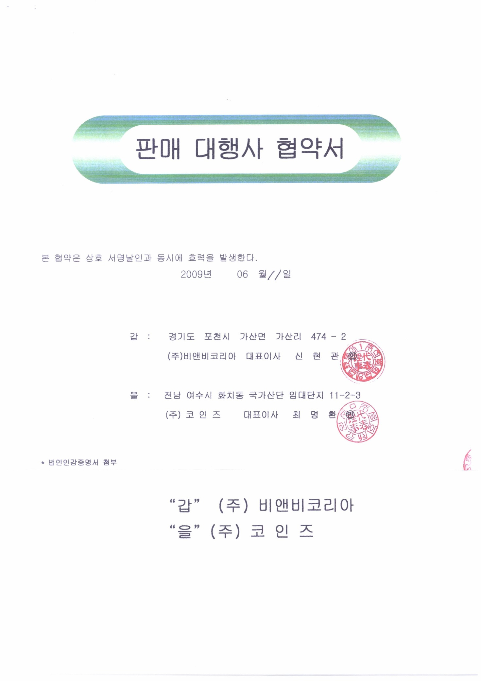
Contract for agency of selling
Ceramic Paint / Coating material

JOBS & SERVICES KOINS DOES

1. Pigging Services
- Engineering, fabrication & supplement of Pig devices and pig material
- Flushing job of new pipelines
- De-scaling job of old pipelines
- Pig decoking of heater/furnace tubes
- Pig lining of pipeline
- Manufacture and supply Launcher / Receiver Trap, Pigging System Engineering
- Hydro and leak test of pipeline
- Intelligent pigging for defect detection
- H/Ex, Condenser Tube Cleaning Service

2. Other Services
[1] Various Cleaning Services
- Heat exchanger cleaning with HPWJ pump(up to 2500bar)
- Pipeline cleaning with rotoflush
- Comprehensive pipeline cleaning with pigging
- Vessel , column and tower cleaning using 3D tank cleaning head
- Chemical Cleaning – pickling and passivation

[2] Catalyst Handling Services (India Branch)
- Catalyst Unloading/Reloading in Tubular Reactors
- General Bulk Catalyst Change-out

3. Material Supplement Services
- Supply installation material
- Supply Ceramic Paint
- Supply rubber foam insulator

Major Customers

LOCAL CUSTOMERS
- Refinery AND Petrochemical Plants
Samsung BP
Chemicals Co., Ltd.
Honam Petrochemical
Corporation
Yeochun NCC Co., Ltd
Hyundai Petrochemical
Co., Ltd.
LG-Dow Chemical
Co., Ltd.
Kumho Petrochemical
Co., Ltd.
Huchems Fine
Chemical Corporation
SK Corporation
S-OIL Corporation
GS-CALTEX
LG Chem. Ltd.
BASF Company Ltd.
Samsung Total
Petrochemicals Co., Ltd.
Namhae Chemical
Corporation

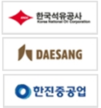
  - Other companies
Korea Gas Corporation
POSCO
SK Energy Co., Ltd.
Korea National Oil
Corporation
Daesang Corporation
Hanjin Heavy
Industries
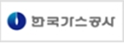
FOREIGN CUSTOMERS

Main references
DOMESTIC JOBS ( CONTRACT AMOUNT OVER THAN US$ 10,000)
DATE | CUSTOMER | JOB DESCRIPTIONS | REMARKS
Mar 2003 | Daesang Corp. | Pig Cleaning for Process Line | 3” x 1.2km
May 2003 | BASF Korea | TDI Project Pipeline Maintenance & Cleaning | 14” x 4.5km
May 2003 | Samsung Total | Pipeline Cleaning | 14” x 1.7km
Nov 2003 | BASF Korea | Evacuation and Cleaning of Nitro-acid Pipeline | 8” x 12.2km
Apr 2004 | LG Petrochem | NCC Furnace Coil Decoking | 2.5” & 4”
May 2004 | Hyundai Petrochem | #1 Complex Pipeline Pig Clean’g & other 9 line: | 14” x 2.2km
Aug 2004 | SK Corp | Inspection w/Intelligent Pig of Oil Pipeline | 14” & 24” x 4.5km
Nov 2004 | GS Caltex | Pig Lining with Vinylester | 10” x 800m
Apr 2005 | LG Petrochem | C/HTR CONV’ COIL Pig Cleaning(NCC Heater) | 2.5” & 4” – 2units
Sep 2005 | Honam Perochem | NCC BA-109 CONV’ UMPH Zone Pig Cleaning | 6”
Sep 2005 | Samsung Total | NCC Heater Convection Pig Cleaning | 2.5” & 4” – 3units
Dec 2005 | LG Petrochem | BPA Plant Pig Cleaning (N₂ Line) | 12” x 350m & 4Sc
May 2006 | GS Caltex | WSR Project Line Cleaning by Pig & HPWJ | 8” x 2.3km X 24
Aug 2006 | Hanjin Heavy  Industrial | Aviation Oil Line Evacuation & Cleaning | 12” x0.5km & 5Sc
Sep 2006 | POSCO | Waste Pipeline Pig Cleaning | 6” and 8” x 850m
Sep 2006. | S-Oil | Raw Water Line Pig Cleaning
Apr 2007 | Kumho Mitsui | HYCO Plant New Pipe Line Pig Cleaning:
Jun 2007 | Samsung Je-IL | MMA 6” Pig Cleaning
Sep 2007 | KoGAS | MokDong~Hapjeong Gas Line Pig Cleaning  : ( preliminary Pigging) w/ROSEN | 20” X 6.4 km
Nov 2007 | LG Chemicals | OXO Plant Heat Exchanger (EC-101) Pigging
Jan 2008 | KNOC | New Pipe Line Cleaning
Apr 2008 | KoGAS | MokDong~Hapjeong Corrosion Inspection : 20” X 6.4 km ( Intelligent Pigging) w/ROSEN | 20” X 6.4 km
Apr 2008 | Lotte-Daesan | Naptha Pipe Line & New Pipe Line Cleaning
Jun 2008 | Kumhopolycheem | Drinking Water Line Pigging
Oct 2008 | Samsung BP | Acid, Surfer Line Pigging
DOMESTIC JOBS ( CONTRACT AMOUNT OVER THAN US$ 10,000)
DATE | CUSTOMER | JOB DESCRIPTIONS | REMARKS
Apr 2009 | Yuyang  Technologies | O₂ Pipeline improvement
Jul 2009 | GS Engineering &  Construction Corp. | NO.3 HOU Project Pig Cleaning
Sep 2009 | Hyundai Heavy  Industrial | LSWR Pipe Cleaning  Between Daesan fireplant and Hyundai oil
Nov 2009 | Inbang Industry | GS-Caltex Pigging
Jul 2010 | Sungchang Heavy  Industries | Honam Perochem B-Project BD AREA
Oct 2010 | Hyundai Engineering &  Construction Corp. | Steam Line Pigging Services
Dec 2010 | Daelim Industrial | Process Pigging
Mar 2011 | Honam Perochem | Naptha Pipeline Pig Cleaning

